Result postgres SQL database designing

Database schema:

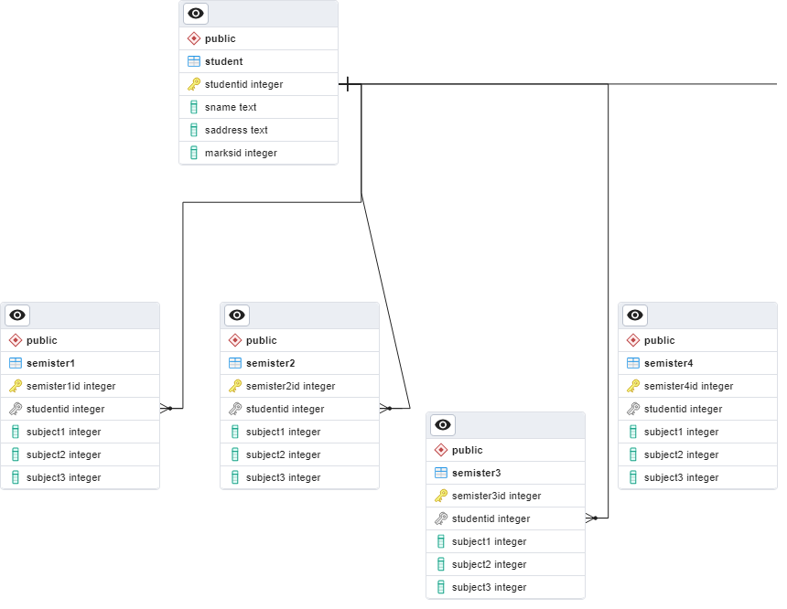

Tables Queries are:

create table student

(

studentid int generated always as identity,

sname text,

saddress text,

marksid int,

primary key(studentid)

);

create table semister2

(

semister2id int generated always as identity,

studentid int,

subject1 int,

subject2 int,

subject3 int,

primary key(semister2id),

constraint fk_student

foreign key(studentid)

references student(studentid)

);

insert into student (sname,saddress) values

('charan','add1'),

('srinivas','add2'),

('akshaja','add1'),

('himaja','add2'),

('sunny','add1'),

('sai','add2'),

('tharun','add1'),

('krishna','add2'),

('chari','add1'),

('sampornashebabu','add2');

insert into semister1

(studentid,subject1,subject2,subject3)

values

(1,20,45,90),

(2,75,45,90),

(3,23,45,5),

(4,20,55,24),

(5,88,35,75),

(6,57,65,90),

(7,12,63,57),

(8,23,43,60),

(9,90,90,98),

(10,65,64,90)

;

select s.studentid,sem.semister1id,s.sname ,sem.subject1,sem.subject2,sem.subject3

from student s

inner join semister1 sem

on s.studentid = sem.studentid;

**Query:**

select s.studentid,sem.semister1id,s.sname ,sem.subject1,sem.subject2,sem.subject3

from student s

inner join semister1 sem

on s.studentid = sem.studentid;

|  |  |  |  |  |  |  |  |
| --- | --- | --- | --- | --- | --- | --- | --- |
| studentid | semister1id | sname | subject1 | subject2 | subject3 |  |  |
| 1 | 1 | charan | 20 | 45 | 90 |  |  |
| 2 | 2 | srinivas | 75 | 45 | 90 |  |  |
| 3 | 3 | akshaja | 23 | 45 | 5 |  |  |
| 4 | 4 | himaja | 20 | 55 | 24 |  |  |
| 5 | 5 | sunny | 88 | 35 | 75 |  |  |
| 6 | 6 | sai | 57 | 65 | 90 |  |  |
| 7 | 7 | tharun | 12 | 63 | 57 |  |  |
| 8 | 8 | krishna | 23 | 43 | 60 |  |  |
| 9 | 9 | chari | 90 | 90 | 98 |  |  |
| 10 | 10 | sampornashebabu | 65 | 64 | 90 |  |  |
|  |  |  |  |  |  |  |  |

**[Total marks query]**

select s.studentid,sem.semister1id,s.sname ,sem.subject1,sem.subject2,sem.subject3

,sem.subject1+sem.subject2+sem.subject3 as "total"

from student s

inner join semister1 sem

on s.studentid = sem.studentid;

**output**

|  |  |  |  |  |  |  |
| --- | --- | --- | --- | --- | --- | --- |
| studentid | semister1id | sname | subject1 | subject2 | subject3 | total |
| 1 | 1 | charan | 20 | 45 | 90 | 155 |
| 2 | 2 | srinivas | 75 | 45 | 90 | 210 |
| 3 | 3 | akshaja | 23 | 45 | 5 | 73 |
| 4 | 4 | himaja | 20 | 55 | 24 | 99 |
| 5 | 5 | sunny | 88 | 35 | 75 | 198 |
| 6 | 6 | sai | 57 | 65 | 90 | 212 |
| 7 | 7 | tharun | 12 | 63 | 57 | 132 |
| 8 | 8 | krishna | 23 | 43 | 60 | 126 |
| 9 | 9 | chari | 90 | 90 | 98 | 278 |
| 10 | 10 | sampornashebabu | 65 | 64 | 90 | 219 |
|  |  |  |  |  |  |  |

**Checking the student passed or fail:**

